0BOverview
The Useful information screen displays a range of links to online services or information outside of MyAccount that may be relevant to MyAccount members.

2BThe Useful information screen.
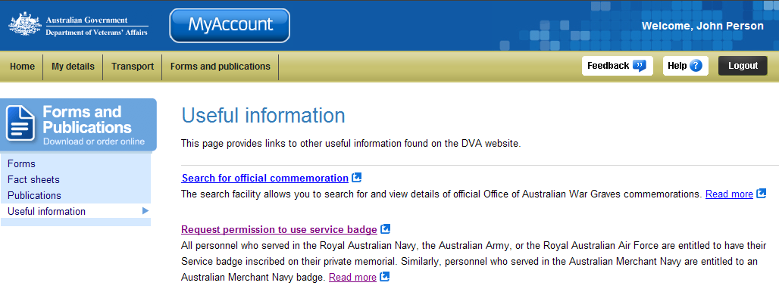
Forms and Publications menu
Links to other services and useful information

The two links displayed will launch a web page outside of MyAccount that provide the services, information or functionality that may be of interest or relevance to you.

1BOther functions
 | To view another section and information from Forms and publications, click on a link in the Forms and Publications menu to the left of the page.
 | To get additional help with the Payments made to you screen, click on the Help button at to the top right of the page.
 | When you are finished using MyAccount, to log out and finish using the service in a secure way, click on the Logout button.

