Overview
Call back service is a new, additional contact method for clients wishing to contact DVA. For your convenience, you may prefer to have DVA call you back using the Call back service in MyAccount. For example, the Call back service may be a more convenient contact method if:
- You are in a rush and would prefer a call back within one working day
- You are on a mobile phone plan and would rather DVA call you back to avoid costly phone charges
- You do not wish to wait on hold regarding your issue
To request a call back from DVA:
- At the top right of the page, click the ‘Call me’ button.
The Call back service screen displays.
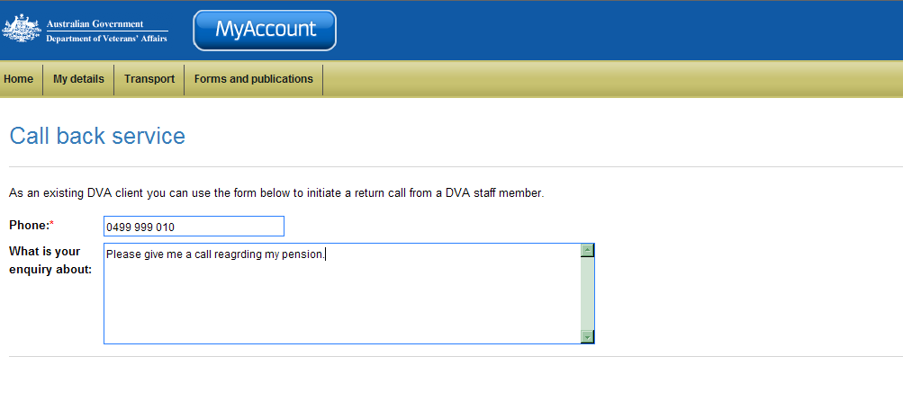
- Enter the phone number you wish DVA to call you back on.
 | Ensure you include your area code and/or country codes if you are calling from overseas.
- In the text box, enter a brief description of what your enquiry is about.
- Click Submit.
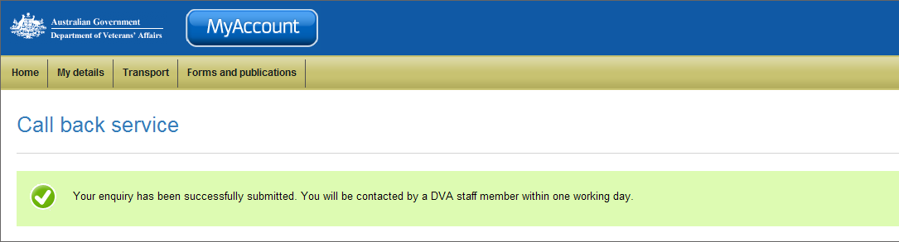
You have successfully submitted a call back using the Call back service. DVA will contact you within one working day.

