Overview
The Upload income and asset documents page allows you to upload additional documents to support any income and asset changes.

The Upload income and asset documents screen.
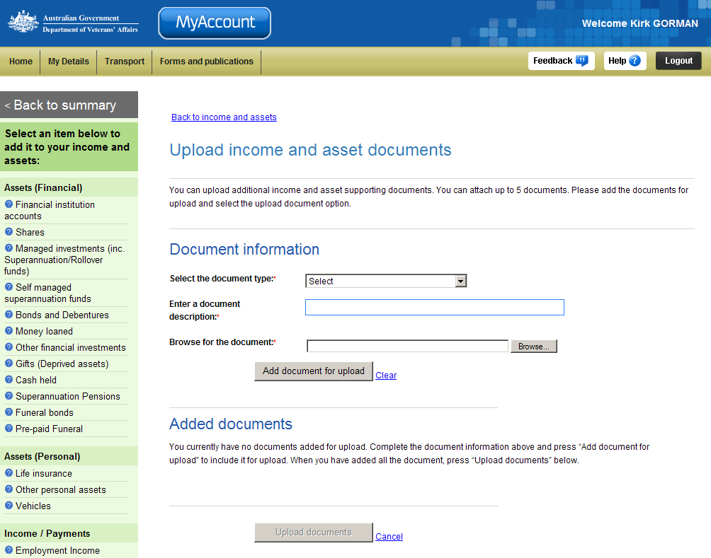
To upload a document:
- From the Select the document type drop down list, select an option that relates to the type of document you are uploading e.g. Investment statement.
- In the Enter a document description field, enter a short description e.g. Shares statement 2013.
- Click on the Browse button to navigate to the document you want to upload.

The Choose file dialog displays.
- Select the document and click on the Open button.
- Click on the Add document for upload button.

The Update income and asset documents screen updates.
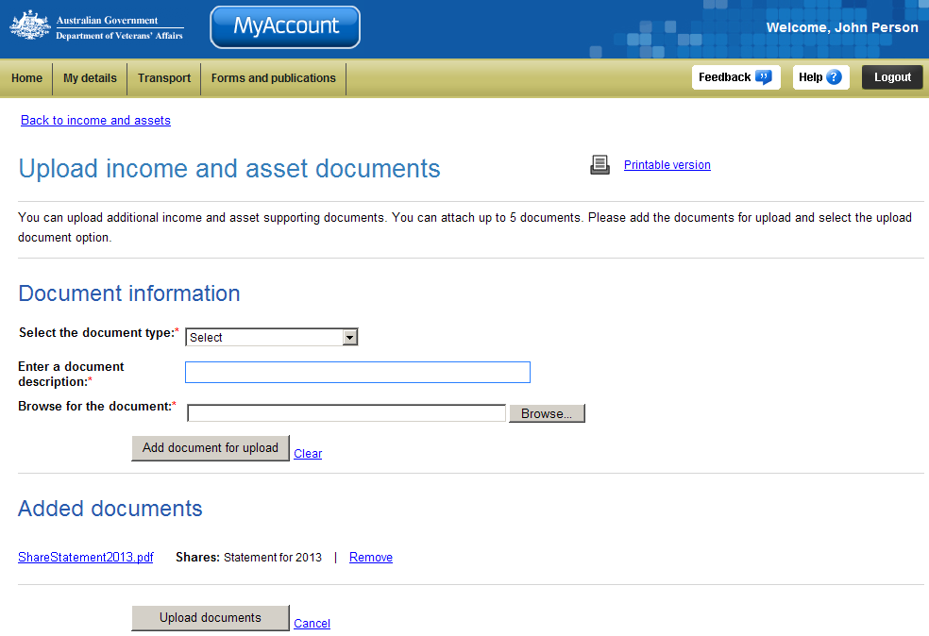
The added document displays in the Added documents section.
 | You can attach up to 5 documents at one time.

- Repeat steps 1-5 to add additional documents.
- Click on the Upload document button.

The Income and assets screen displays.
A success message displays indicating your changes have been submitted and the details displayed will be updated once DVA processes the changes.

Other functions
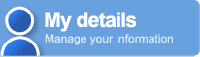 | To view another section and information from My details, click on a link in the My details menu to the left of the page.
 | To get additional help with the Upload income and asset documents screen, click on the Help button at to the top right of the page.
 | When you are finished using MyAccount, to log out and finish using the service in a secure way, click on the Logout button.

