Overview
From the Publications screen you can download a range of DVA publications in PDF format.

The Publications screen.
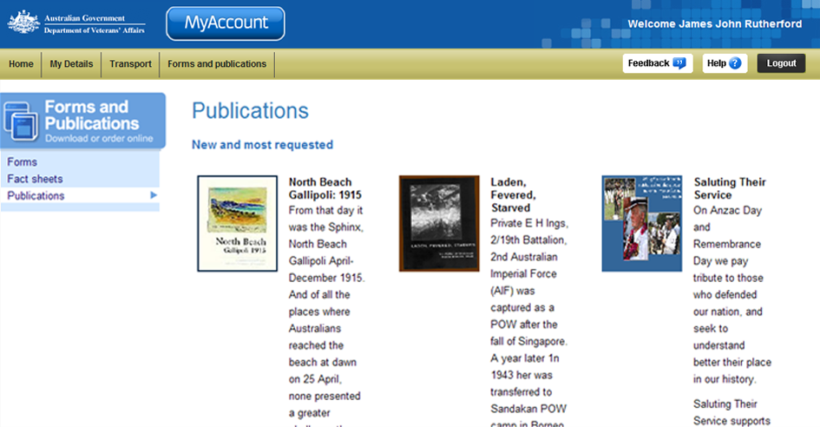
Forms and Publications menu.
New and most requested publications.

New and most requested
Six publications that are either new or the most requested are displayed in the first section at the top of the screen.

Other publications
Below the New and most requested section, additional publications are grouped according to type. To expand a group, click on the icon (twistie).

Download a publication
To view downloaded publications you need a copy of Adobe Reader (or Adobe Acrobat). This may already be installed on your computer.
If required, you can get a free copy of Adobe Reader at: http://get.adobe.com/reader/
To download and print a publication:
- For New and most requested publications, click on the Download PDF link located below the publication name and description text.
For Other publications, click on the Download PDF link to the right of the publication name and description.

The File Download dialog box displays.
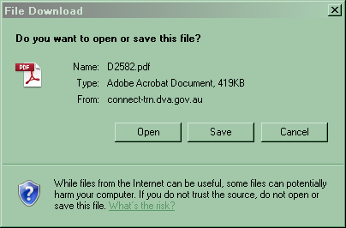
- Click on the Open button.

The publication displays in Adobe Acrobat or in your web browser.
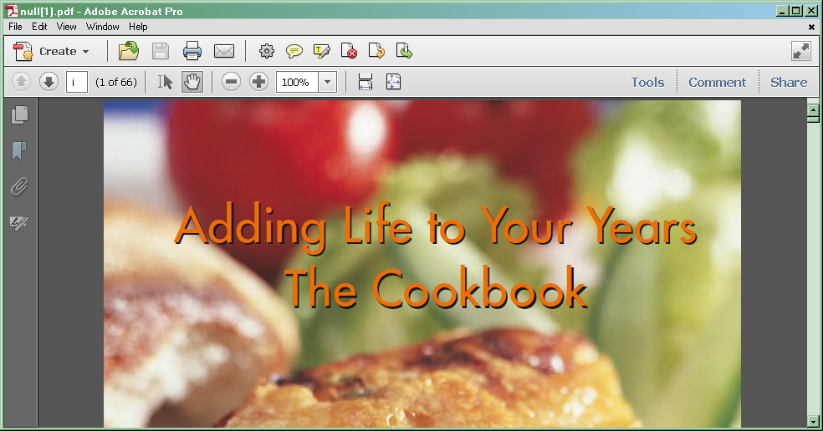
- To print the publication, click on the icon on the toolbar or click on the File menu > Print...
- To save a copy of the publication, click on the File menu > Save As… > PDF… and choose a location and file name for the publication.

Other functions
 | To view another section and information from Forms and publications, click on a link in the Forms and Publications menu to the left of the page.
 | To get additional help with the Publications screen, click on the Help button at to the top right of the page.
 | When you are finished using MyAccount, to log out and finish using the service in a secure way, click on the Logout button.

