Overview
The Payments made to you screen displays detailed information on the five most recent payments made to you by the department.
You can retrieve further payment records for payments made any time in the last 90 days from this screen.

The Payments made to you screen.
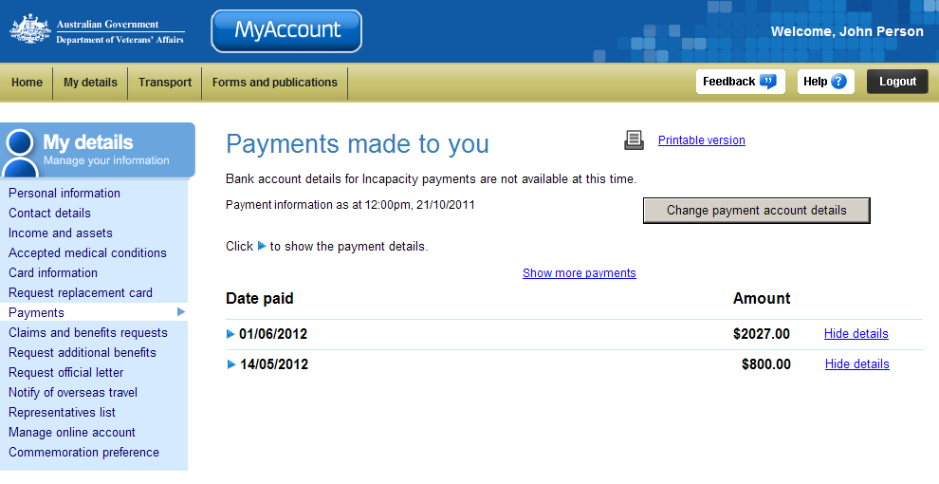
My details menu
Change payment account details
At the top of the screen, under the title, the time and date when the MyAccount record was most recently updated is displayed.
 | Payment account details can be changed by selecting the ‘Change payment account details’ button.

View payment details
For each payment, information is displayed in a summarised view with only the payment date and total amount displayed.
- To view more information on a payment, click on the icon (twistie) or click on the View Details link to the right of the payment amount.

The Payments made to you screen updates.
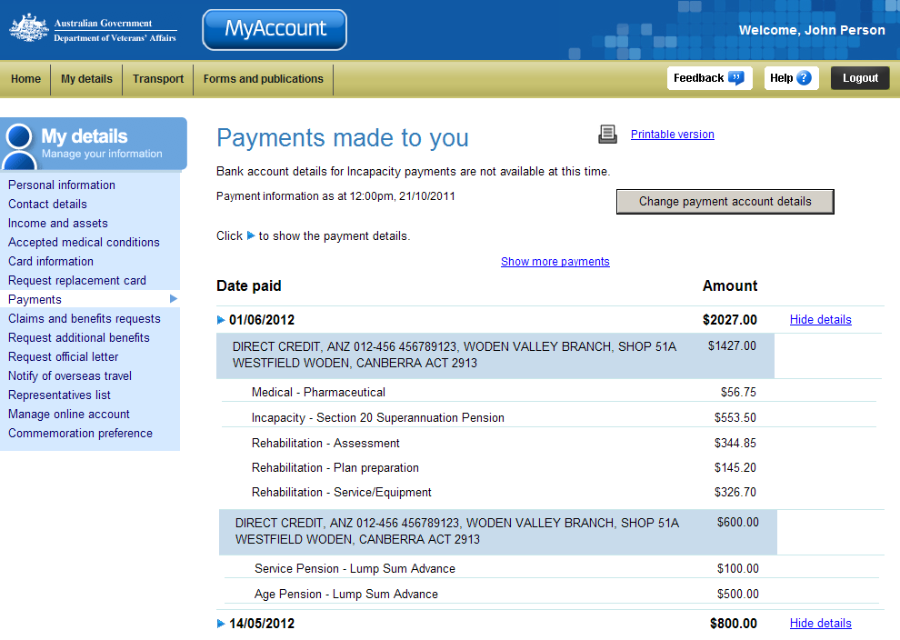
Payment method
Payment types
For each payment, the payment method is displayed in a blue box. This includes the amount, bank account and branch information where the payment was made.
For each payment, a list of payment types (for example, service pension, income support supplement, etc.) and the their amounts is displayed.
- To display less information, click on the icon (twistie) or click on the Hide Details link to the right of the payment amount.

Display more payment records
You can retrieve payment records for payments made any time in the last 90 days.
- To view older payment records, click on the Show more payments link at the bottom of the page.

The Payments made to you screen displays.
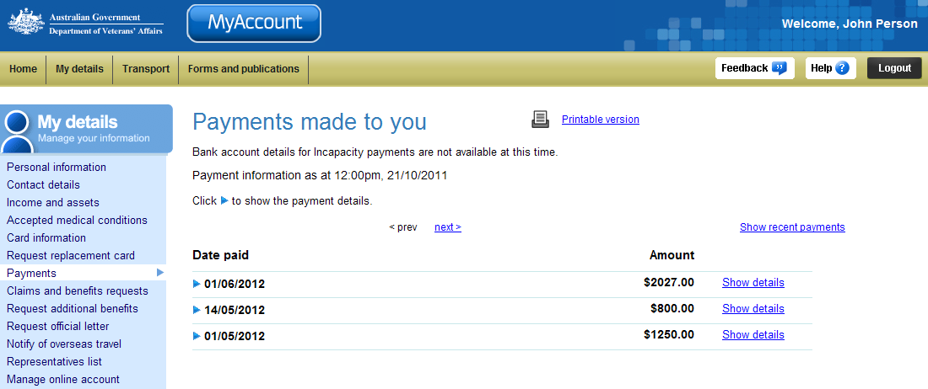
Up to 20 payments are displayed on a page.
- To view the next (or previous) page, click on the < prev or next > link at the top or bottom of the page.
- To view your five most recent payments, click on the Show recent payments link at the top or bottom of the page, on the right side.

The Payments made to you screen displays.
You have successfully displayed more payment records.

Other functions
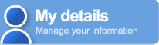 | To view another section or perform another transaction related to my details, click on a link in the My details menu to the left of the page.
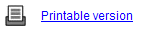 | To print a copy of the information displayed on this page, click on the Printable version link.
 | To get additional help with the Payments made to you screen, click on the Help button at to the top right of the page.
 | When you are finished using MyAccount, to log out and finish using the service in a secure way, click on the Logout button.

