Overview
The Inbox is a screen that allows direct correspondence between yourself and DVA.

The Inbox screen
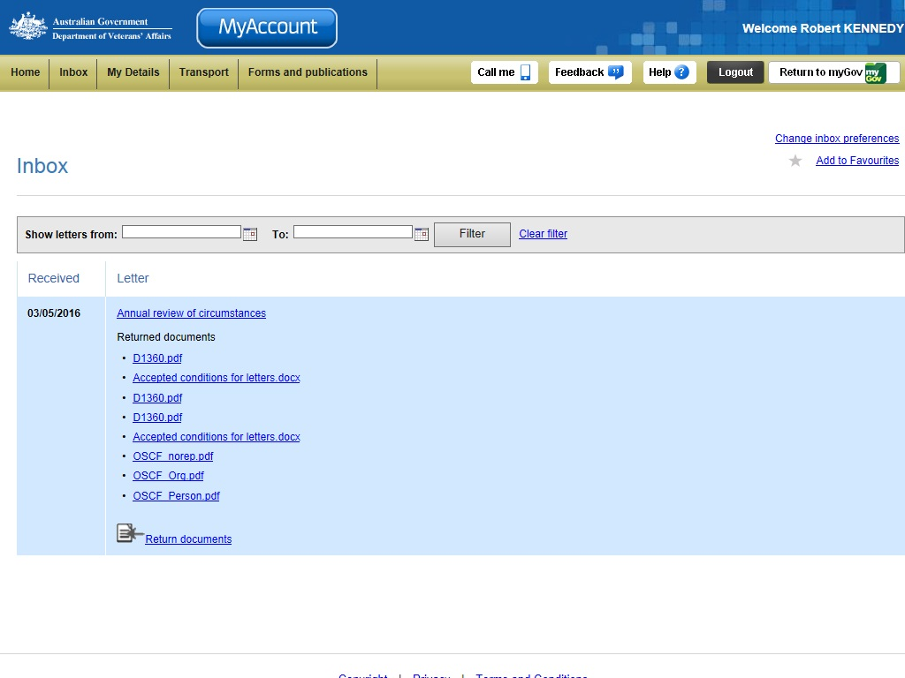
Incoming correspondence and attachments
Email preferences and Inbox filter
Claim-related correspondence sent to you from DVA will be available for you to access from the MyAccount Inbox screen. The Inbox will display correspondence as lists containing links to the letters, as well as links to any attachments that have been included in the correspondence.
You can also direct correspondence back to DVA. By using the Return documents link you can send requested supporting documentation directly back to the person/s looking after your application.

Viewing your letters
You can view letters from the inbox quickly and easily.
The following process is used to view your letters.
- In the Inbox screen, click the letter link.
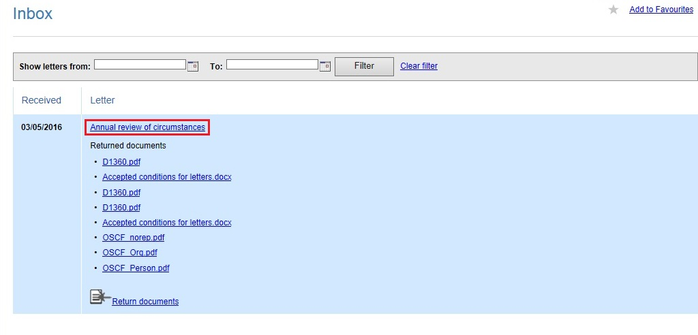
The letter will display.
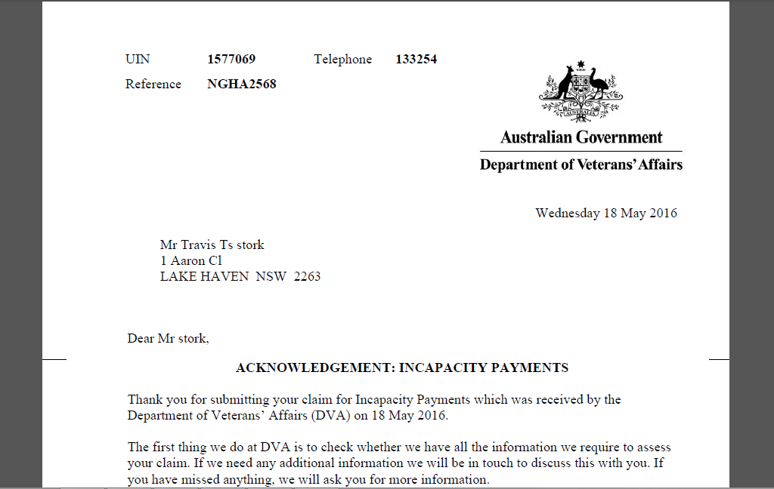

Returning documents
You can return documentation in direct response to the letter requesting it. By returning the documents in response to the letter you are ensuring the documentation is delivered directly to the person/s look after your application, and the documents will be linked directly to your claim.
The following process is used to return documents.
- In the Inbox screen, under the letter you are replying to, click the Return documents link.
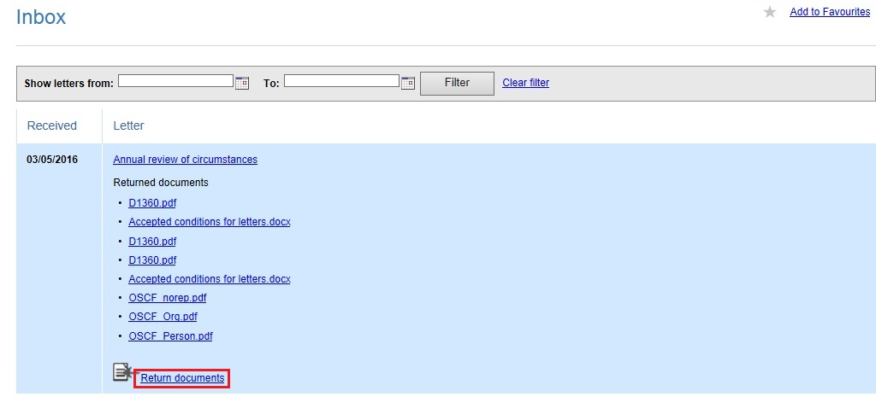
The Return Documents window will display.
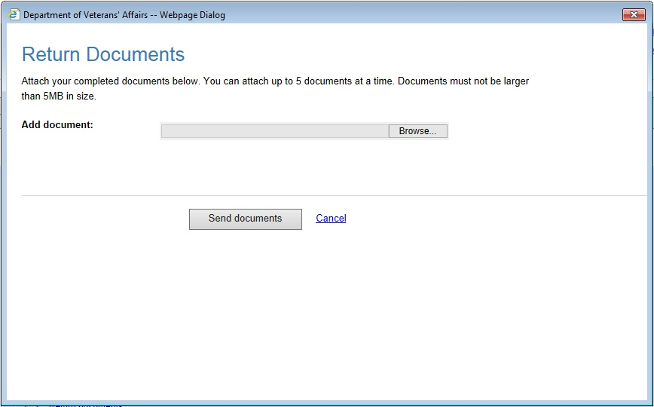

- In the Return Documents window, click the Browse button.
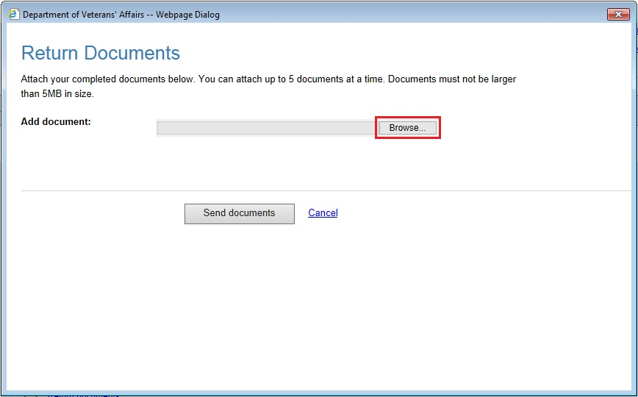
The Choose File to Upload window will display.
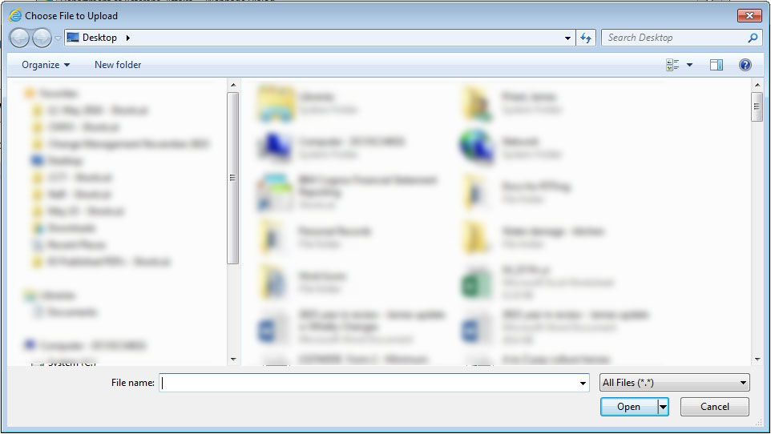
- In the Choose File to Upload window, select the file you wish to upload.
- Click the Open button.
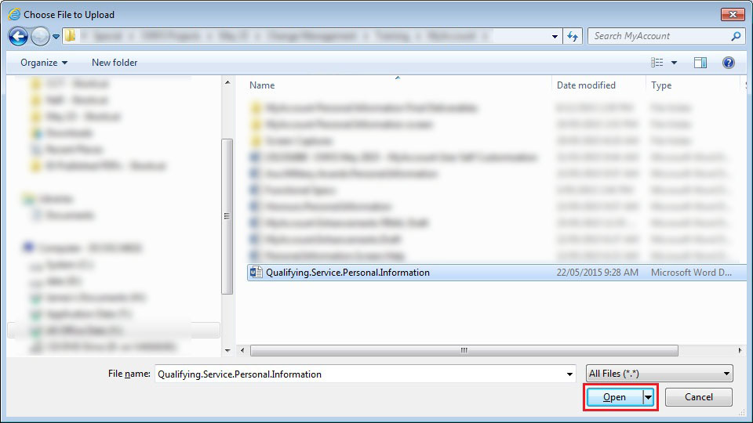
The Return documents window will display again. The details of the document you are uploading will display.
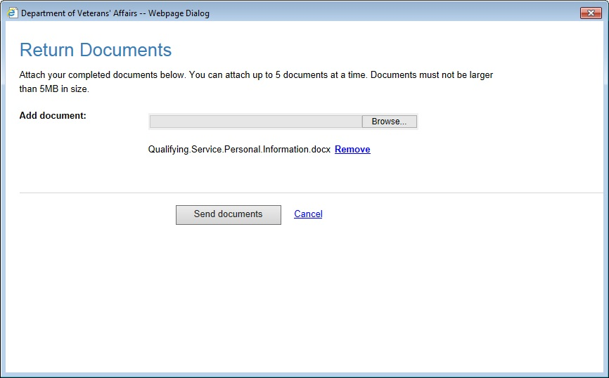
Note: You can click the Browse button again and load another document for sending. You can upload and send a total of five documents at a time.
- Click the Send documents button.
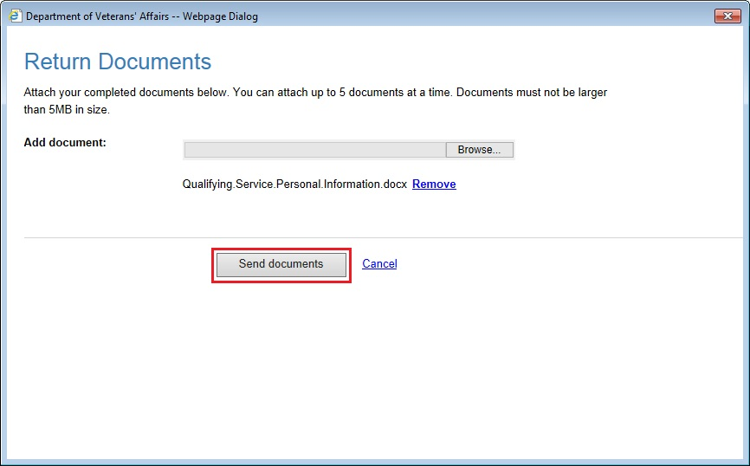
The Inbox screen will display again. A green banner will display advising the file successfully uploaded.
