Overview
The Income and assets screen displays detailed information of the records DVA holds on income and assets for yourself and your partner (where applicable).
 | You can change and upload documents for these income and asset categories by clicking the ‘Update income and / or asset’ or ‘Upload documents’ buttons.

The Income and assets screen.
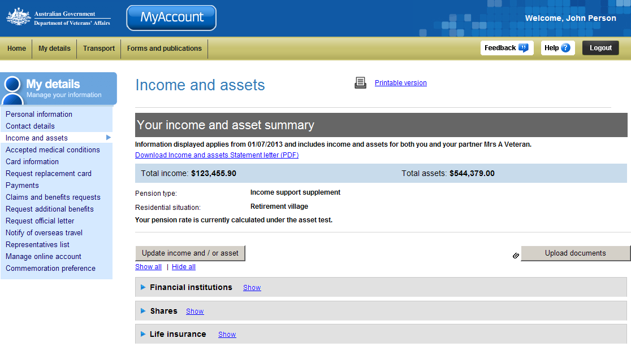
My details menu
Details of Pension type
and Residential situation
Upload documents
Update income and asset details

Income and assets information is organised into categories (grey headings):

- Financial institutions
- Shares
- Life insurance
- Managed investments (including Superannuation)
- Bonds and debentures
- Funeral bonds
- Cash held

- Estate payments
- Home contents
- Loans
- Other financial investments
- Other direct income
- Businesses and trusts
- Vehicle
- Other personal assets

Categories only display if DVA holds details for you about these income / assets.

View income and asset information
To view your income and asset information:
- Click on the icon (twistie) or alternatively click on the Show link in the category heading.

The Income and assets screen updates.
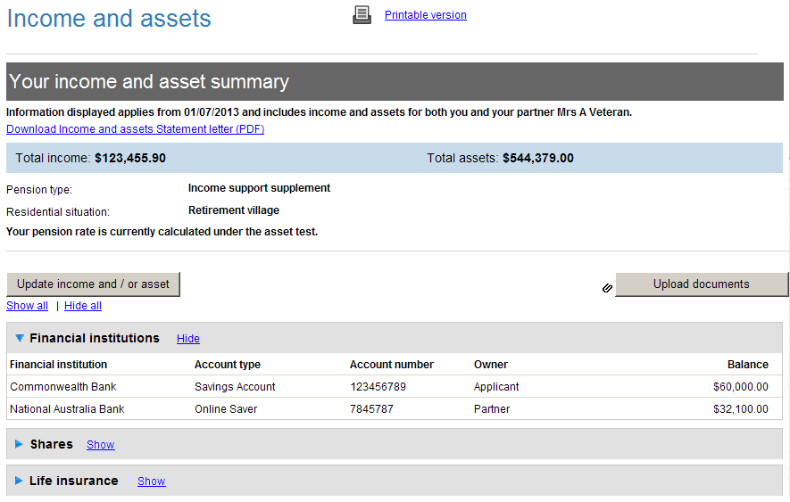
Hide / show financial assets details
Your income / assets details will be displayed.
- Scroll down to view all information in this section.
- Click on the Hide link to hide the details.

Download and print income and assets statement letter
To download and print an income and assets statement letter:
- Click on the Download Income and assets Statement Letter (PDF) link.

The File Download dialog box displays.
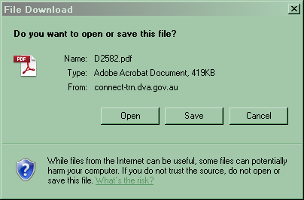
- Click on the Open button.

The letter displays in Adobe Acrobat or in your web browser.
- To print the letter, click on the icon on the toolbar or click on the File menu > Print...
- To save a copy of the letter, click on the File menu > Save As… > PDF… and choose a location and file name for the letter.

Print the screen display
To print the screen display:
- Select / expand the income and asset categories you want to print by selecting the links or icon.
- Click on the Printable version link to print the screen.

The print dialog box will display.

Other functions
 | To view another section or perform another transaction related to my details, click on a link in the My details menu to the left of the page.
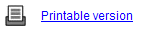 | To print a copy of the information displayed on this page, click on the Printable version link.
 | To get additional help with the Income and assets screen, click on the Help button at to the top right of the page.
 | When you are finished using MyAccount, to log out and finish using the service in a secure way, click on the Logout button.

